**Collision Avoidance: A Primer Concerning How Automated Vehicles Will Interact with the Law and the Judiciary**

**By Ian Adams[1]**

* **Introduction**

The arrival of automated systems, in both commercial and passenger vehicles, has been touted for years. But the development and hype around the technology has long outstripped its real-world implications. In the third decade of the 21st Century, that state of affairs is set to change. The question: How ready is the law, and the judiciary that applies it, for the cases and controversies that will inevitably follow the deployment of automated systems?

In 2020 The National Judicial College (NJC), with support from the Federal Motor Carrier Safety Administration (FMCSA), began a program to improve road safety by helping judges become familiar with this technology, the law as it currently exists around it, and the concrete questions that automated systems – particularly on commercial motor vehicles like semi trucks – will bring to their courtrooms. The ultimate goal of this effort is to craft a curriculum for judges to undertake at the NJC that will equip them to navigate this quickly changing area of the law.

The NJC convened a steering committee made up of roughly 20 judges, industry experts and academics to identify areas most in need of explication. The group’s inaugural event, Collision Avoidance: How Automated Vehicles Will Interact with the Law and the Judiciary, was split into four sessions over two days. Each session consisted of two parts: presentations available to any NJC members of the judiciary; and a series of small-group guided discussion sessions for the steering committee immediately after each presentation.

What follows is a substantive overview of the program, a discussion of feedback from the larger group and steering committee, and a catalogue of recommendations for the steering committee to explore in subsequent convenings.

* **A Conversation in Four Parts**

Event attendees were given an overview of automated vehicle technologies that assumed no familiarity with the technical aspects or the legislative or regulatory landscape surrounding them. Over two days the program endeavored to equip participants for ever-more-granular conversations culminating in the consideration of the real-world challenges posed by automated commercial vehicles.

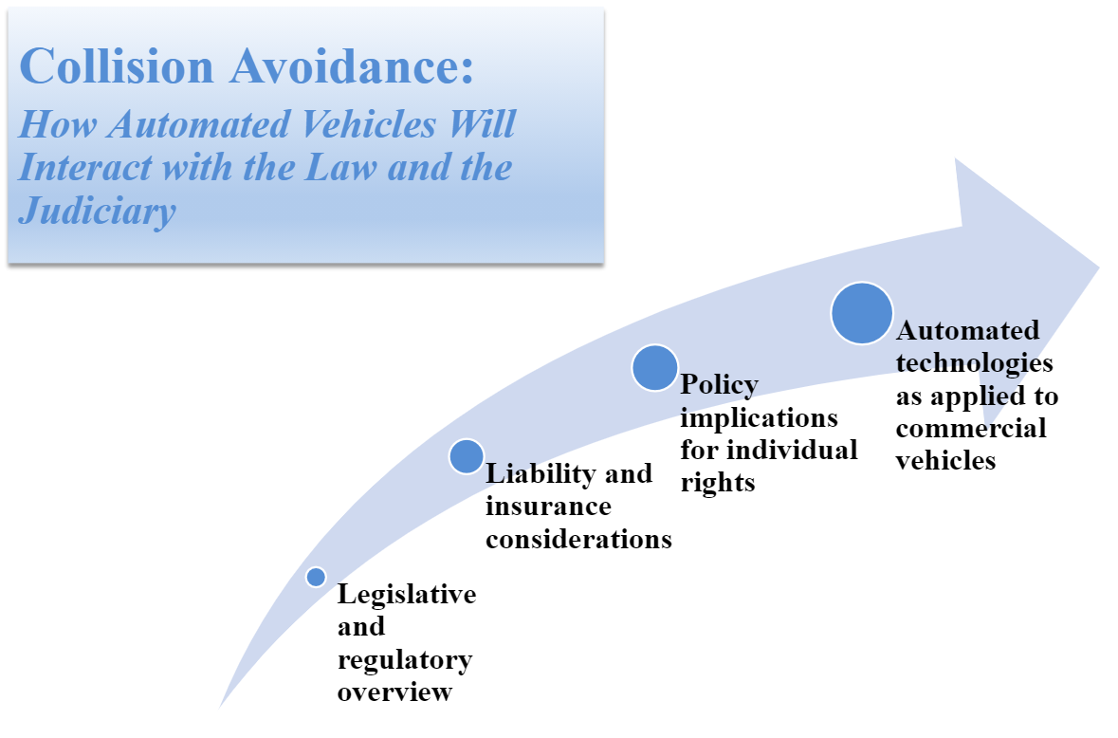

At the conclusion of each presentation, the larger group in attendance responded to prompts to gauge their impressions of unresolved questions in the field. From there, the steering committee convened in closed sessions to discuss both the larger group’s reactions and to explore questions raised by the presentations. In doing so, the steering committee was both able to refine its own understanding of the material and to bring the perspective of the judiciary to bear on the questions of greatest significance to its operation.[2]

* **Session One**: An overview of the Highly-Automated Vehicle (HAV) legislative and regulatory environment[3]

The first presentation focused on exactly what an automated vehicle is (and isn’t) while also providing an overview of the law, regulation, and informal guidance that currently exists related to the technology. Additionally, the presentation covered the differences between spheres of federal and state authority and the distinctions that have emerged among the regulatory approaches to the technology taken by various states. At the conclusion of the presentation, the large group was presented with the following questions:

* + Q1: Is informal guidance sufficient to sustain the ongoing development and deployment of HAVs?[4]
    - Yes - 19%
    - No - 79%
  + Q2: Is federal legislation necessary?
    - Yes - 60%
    - No - 36%
  + Q3: If the law has not explicitly legalized the operation of HAVs, would you consider the operation of such vehicles to be legal or illegal?
    - Legal - 51%
    - Illegal - 44%

The responses are striking for a number of reasons. First, the fact that 79 percent of respondents to Question 1 do not believe that informal guidance is sufficient for purposes of HAV development and deployment suggests that they believe the status quo at the federal level, in which the Department of Transportation (DOT) publishes annual informal guidance to HAV developers, must change and that legislation should be adopted to resolve ongoing ambiguities.

Interestingly, the second question finds support for federal legislation, but it is significantly lower than the share concerned about the sufficiency of informal guidance. By negative implication, this may suggest that states have a more robust role to play in addressing the particular areas of concern to judges. These areas would likely involve the application and enforcement of traffic laws and liability considerations, which are traditionally under state control. In other words, while a majority of the group believed that greater clarity from the federal government is necessary, it appears that federal legislation is not sufficient to address the concerns of judges given the areas of responsibility traditionally left to the states.

The ambivalence reflected in Question 3 is, likewise, striking. In the absence of enabling legislation, nearly half of those surveyed have concerns about the legality of operation of HAVs on the roads today. This is notable in light of the fact that the DOT has issued interpretive guidance granting permission-to-operate to technologies without a human operator. It also underscores the general preference among participants for conspicuous lines of authority.

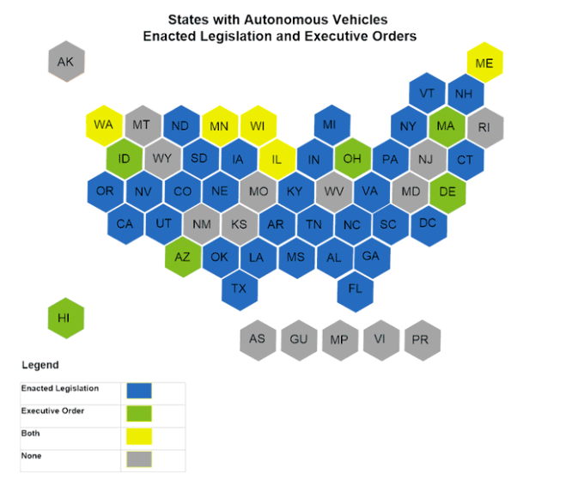

* + **Steering Committee Discussion**

The steering committee’s first conversation focused on the challenges posed by the so-called “pacing problem.”[5] That is, on the problem presented by technology and the law developing out of tandem with one another. To date, informal guidance from federal and state officials has offered a flexible framework that has allowed for testing and limited deployment of automated systems. But while this framework has effectively made way from a technical perspective, the steering committee expressed concern that it has left the law – and the judiciary in particular – in an untenable position.

Many participants believed that the law should lead technology, even if some innovative applications are left on the table as firms wait for legislative and regulatory approval. But others responded that the common law offers a backstop that will empower judges to rule on cases in which automation is implicated.

Regardless of the path forward, there was consensus on the need for clear and widely articulated/adopted definitions related to automated technologies. This would allow judges to promulgate reasonable decisions that could be used as universalizable precedent. As one judge pointed out, in a concrete sense, the need for definitional clarity is a threshold matter for purposes of assessing the credibility of expert witnesses who will be vital as courts consider cases involving automated vehicles.

With respect to commercial vehicles, in particular, the committee was generally sympathetic to the need for licensing and hour-of-service considerations to evolve. However, applying the pacing problem to the law as it currently stands, most judges on the committee expressed a preference for erring on the side of adhering to non-automation-specific guidance in the absence of imposing a judge-made standard.

* **Session Two:** The Liability Question and the Role of Insurance[6]

The first day’s second session was dedicated to the liability considerations around automated technologies and the manner in which traditional legal standards and approaches to attributing responsibility will face challenges as they arrive. Secondarily, the session covered how insurance, as the most common risk-transfer tool, may need to change to accommodate novel exposures created by automated technologies. At the conclusion of the presentation, the participants were asked:

* + Q1: Should the laws that govern liability for HAVs be decided on a state level, a federal level, or a combination of the two?
    - State - 25%
    - Federal - 12%
    - Both - 63%
  + Q2: If a controversy involving an automated vehicle were to come to a courtroom today, do the tools exist to appropriately resolve the matter?
    - Yes - 33%
    - No - 67%

The first question built upon the federal and state distinction of the previous panel but did so in light of the presentation’s detailed discussion of the limits of current state-based liability regimes. Thus, in spite of the fact that vehicular liability is traditionally dictated at the state level, participants saw value in the federal government taking a role. While such a role for the federal government would be novel, the impulse for uniformity among the states was a frequent theme among participants and likely motivated some respondents.

The second question, about the readiness of courts to resolve controversies involving automated vehicles, saw two-thirds of participants signal that they do not believe courts are prepared to adjudicate disputes involving automated systems. Perhaps more than any other, this response underscored just how vital it is that the NJC work to equip judges to approach cases involving automated systems with confidence.

* + **Steering Committee Discussion**

Going into the day’s curriculum, the most talked about issue among the judges was how exactly the presence of an automated system would impact liability in the wake of an accident. And, as a related matter, how such liability could be ascertained. Based upon the morning’s conversation, committee members became familiar with the levels of automation employed by driverless systems, which further complicated the question.

In the breakout session, the group concluded that while accidents involving Level 0-2 vehicles could be handled by existing negligence analysis, Level 3-5-equipped vehicles would likely involve a product liability analysis – provided the system was in control when the accident occurred. Further complicating any analysis is the role that connected infrastructure may play in the deployment of automated systems. Thus, an aggrieved party may have to seek redress from a vehicle operator, manufacturer and/or municipal entity to resolve their complaint.

One judge pointed out that the trouble with this state of affairs is that such suits would be discovery heavy, hugely technical, and prohibitively expensive to resolve. Several committee members shared anecdotes about how difficult it is to share data among manufacturers and those outside of the automated system’s stack.

To address these issues, the committee discussed the role of alternative dispute resolution and the need for pre-accident agreements between vehicle manufacturers and insurers. Ultimately, in the absence of such forethought, the committee was generally pessimistic about a court’s ability to resolve accidents involving automated systems.

Regarding commercial vehicles, the membership considered the challenges associated with particular automated systems that are engaged at certain times but not others. That scenario is particularly relevant given that commercial vehicles are being deployed with discrete systems to assist with specific driving tasks like platooning. A member of the committee pointed out that having a safety system turned off that could have otherwise prevented a collision may itself inform the negligence analysis judges undertake on trucks on the roads today. To wit, automation is changing the way in which judges assess road safety even when it is not being actively employed.

* **Session Three**: Privacy, Security and Civil Rights[7]

The second day’s first session detailed the challenges and opportunities presented by automated technologies in the context of the myriad policy issues that they implicate for the judiciary. Namely, personal privacy, security and civil rights. This presentation was specifically geared toward the technology’s implications for law enforcement and the communities that police serve.

* + Q1: All things considered, will HAVs be a net positive or negative for individual rights?
    - Net positive - 35%
    - Net negative - 33%
    - No impact - 33%
  + Q2: Will HAV operations demand new sector-specific privacy protections for individuals?
    - Yes - 50%
    - No - 16%
    - Unsure - 33%

Participants were remarkably evenly split in their view of the impact that automated systems would have on the rights of individuals. While none of those responding had any special insight into how rights will fare in an era defined by automation, the answers illustrated that attitudes toward automation and automated technologies vary widely. And given how much of the law related to automated systems will be driven by individual judges, nascent attitudes toward automation will likely have an outsized impact on cases of first impression.

With regard to privacy, specifically, participants tended toward the view that new sector-specific regulation would be necessary to ensure protection of both riders’ and bystanders’ interests. This attitude is consistent with the general mood of the public and policymakers that more must be done to preserve the privacy of individuals in an age of abundant information.

* + **Steering Committee Discussion**

The committee’s discussion following the third presentation was primarily focused on the public’s expectations of how automated technologies will operate and about how those expectations will influence claims involving automated systems. That is, whether individual perceptions about privacy and data security will encourage litigants to come to court with their concerns, and if that, in the absence of clear and uniform standards, will lead to disparate findings.

To that end, one judge raised the experience courts had with the deployment and adoption of Event Data Recorders (EDRs). States took different approaches to who owns what and, therefore, who should have access to accident data. Ultimately, predictability around how such data should be treated took roughly a decade to develop organically. Considering that an EDR is a single system, and that automated vehicles are an order of magnitude more complex, the judges came to a consensus that court-developed law related to automated systems would take years longer to coalesce.

In light of that lag in public perception and court-made law uniformity, during the commercial vehicle portion of the conversation, the group considered how current informal FMCSA guidance is likely going to be of more importance as judges evaluate standards that may become absurd on their face in the context of automated systems. For instance, if applied rigidly, do standards around the certification of vehicle inspectors, which require one year of experience on “similar vehicles,” offer enough flexibility?

Directionally, this greater comfort with the need for “soft law” was in contrast to some of the consensus reached the day before about how law should lead technology. Ultimately, the group encouraged federal regulators to proactively anticipate, by way of interpretive guidance, existing rules that may be challenged by new technologies to give judges an expert opinion to hang their hats on when cases involving commercial automated vehicles come to their courtrooms.

* **Session Four**: The Special Case of Automated Trucking[8]

The event’s final session was dedicated to automated systems that are, and will be, affixed to commercial vehicles. In particular, the session detailed the types of systems and specific technologies that trucks are likely to employ, how trucks will collect and process information, and the way in which trucking licensure and licensing enforcement will be impacted by automated systems.

* + Q1: Based upon what you’ve seen, are trucking platforms well positioned to safely deploy automated systems?
    - Yes - 43%
    - No - 49%
  + Q2: Are regulators and law enforcement in your jurisdiction prepared to interact with automated trucks?
    - Yes - 9%
    - No - 89%

Safety is essential to the successful deployment of commercial automated systems, given the size and variability of the cargo they will be asked to carry. Thus, while the presentation went to great lengths to describe the real-world testing and deployment protocols that firms developing automated commercial trucks undertake, a majority of respondents still signaled that they are skeptical about whether such systems can currently be safely deployed. More telling, nearly 90 percent of respondents, at the end of two days of intensive education, believed that both regulators and law enforcement are not prepared to interact with commercial automated systems.

The latter question may lend some insight into the former because if members of the judiciary are skeptical of the ability of regulators and law enforcement to interact with automated systems competently, they may well consider such systems inherently unsafe to deploy.

* + **Steering Committee Discussion**

The event’s final steering committee conversation drilled into the details of how the judiciary will interact with commercial vehicles equipped with automated technologies. The most significant challenge identified by the judges related to the reliability and interpretation of otherwise seemingly objective data produced by automated sensors.

By way of example, one participant pointed out that while automated systems will produce untold amounts of data that might be used to ensure compliance with various FMCSA standards, roadside inspections will remain necessary to ensure systems are functional. Today, those inspectors are not equipped to assess such systems reliably or act as expert witnesses for courts.

Likewise, in the wake of an accident, reconstructing what occurred after the fact will be more challenging than is immediately apparent. For instance, just because a recording of an accident exists doesn’t mean that an expert can ascertain the speed a vehicle was moving. Indeed, to do so would require the expert to understand and account for the frames per second at which the video was captured.

In each case, the judges present reiterated the need for understanding the nature of automated systems, how the “stack” of technologies interacts. For instance, while lots of data are collected, their storage is not practicable for long periods, so the expectation that they will exist in all cases is misplaced. Relatedly, they expressed concerns around how they would be asked to assess the credibility of expert witnesses to conduct trials economically and avoid the misapplication of the law.

Finally, the group gave further consideration to the manner in which automated systems may mitigate the masking of offenses committed by CDL holders in state courts by way of a system that could be relied upon to communicate certain infractions to FMCSA directly. Judges were generally of the opinion that, by virtue of the fallibility of automated systems and the interpretive challenges highlighted earlier in the conversation, there must remain a human component in the assessment of wrongdoing.

* **Emergent themes and recommendations**

At the conclusion of the two-day meeting, three large themes emerged from judges to inform the steering committee’s path moving forward. These themes get to the core of the challenge that judges will face as they are confronted with new and changing automated systems.

**1. The limits and necessary application of informal guidance**

At the time of publication, there is no formally promulgated law or regulation from the federal government concerning automated vehicles. However, that is not to say that the Department of Transportation and its associated entities have been quiet in the space.

For years now, DOT, FMCSA and NHTSA have been releasing informal guidance for the developers and manufacturers of automated systems. Everything from interpretive guidance clarifying the definition of a “driver” to specific judgments around the deployment of camera-operated side-view mirrors.

It is unlikely that the development and deployment of automated systems will pause as the law catches up, so there is a balance that must be struck to provide courts with insights necessary to dispose of matters involving those technologies.

Necessarily, this “soft law” does not control or preempt mandatory legal authorities, but in the face of novel technologies that may render some existing laws redundant or absurd, it is vital that federal regulators both tailor and expand the scope of their informal guidance to questions confronting the judiciary.

Recommendation: The steering committee should identify discrete areas of law that require additional, or clarifying, informal guidance. With an eye toward providing judges with tools necessary to interpret these areas, the steering committee should work with regulatory partners to refine a curriculum for judges to highlight the state of that guidance.

**2. The need for judicial and regulatory capacity building**

In the large-group survey questions and throughout the steering committee’s convenings, participants consistently highlighted how regulators, law enforcement and the judiciary are unprepared for the widespread deployment of automated systems.

Some of this concern is likely borne of a lack of familiarity with the technology since it has yet to be widely deployed. But some of it also comes from an awareness that existing structures are ill-equipped to handle the types of questions raised by automated systems.

Thus, there is a need not just for the law to evolve but for personnel and structures within law enforcement, the regulatory state, and the judiciary to do so as well. The steering committee is well-equipped to identify the areas which will face strain.

Recommendation: The steering committee should walk through a series of factual scenarios with an eye toward identifying the ways in which each step would increase and/or decrease the burden on the court and the parties before it.

**3. How to discern relevant witness expertise**

Courts of general jurisdiction, and even courts dedicated to handling vehicle-related disputes, rely upon expert witnesses to offer insights and guidance that shape the understanding of factual predicates to the court’s ultimate decision. But the experts of today may not be the experts of tomorrow, and courts need to become familiar with how to evaluate which experts have the relevant expertise to testify competently to the issue at hand.

Recommendation: The steering committee should convene a discussion with technical experts to identify and refine readily utilizable standards for the evaluation of experts on automated systems.

* **Conclusion**

Courtrooms are not legislative assemblies. While courts are sometimes asked to synthesize rules in novel situations, their primary purpose is the application of legal principles to facts. That’s why automated systems present such a challenge for the nation’s courts: they combine incredible complexity with a large universe of stakeholders in an unsettled area of law.

For this reason, the NJC’s automated vehicle steering committee’s efforts to identify the hurdles awaiting unknowing jurists are vital for a smooth integration of such matters onto dockets everywhere.

1. Ian Adams is executive director at the International Center for Law & Economics, a public policy think tank, and an attorney with the international law firm Orrick, Herrington & Sutcliffe LLP. His experience in the automotive technology and mobility industry includes testifying before Congress about HAV deployment and regulation, as well as representing clients AIMotive, Baidu, Getaround, NVIDIA and Scotty Labs.
2. Note that steering committee members observed Chatham House Rules during their breakout sessions. To wit, the identities of speakers are not included in this document.
3. Presentation by Jennifer Huddleston, Director of Technology and Innovation Policy at the American Action Forum
4. Note that not all session attendees responded to each question, therefore percentage totals do not always come to 100 percent.
5. Further reading available here: “The Pacing Problem and the Future of Technology Regulation” by Adam Thierer. https://www.mercatus.org/bridge/commentary/pacing-problem-and-future-technology-regulation
6. Presentation by Ryan Gammelgard, counsel in State Farm Mutual Automobile Insurance Company’s corporate law department
7. Presentation by Caleb Watney, Director of Innovation Policy at the Progressive Policy Institute
8. Presentation by Dr. Çetin Meriçli, CEO and cofounder of Locomation, the world’s first trucking technology platform to combine AI-driven autonomy with driver augmentation